**Haryana**

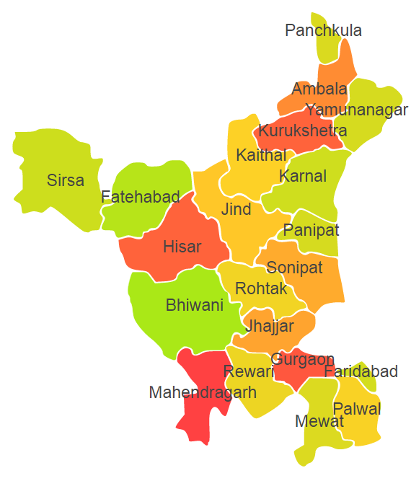

Haryana comprises of three Agro Ecological Region (AER) 2, 4 and 9.

**Agro-Eco Region 2 :** AER 2 in Haryana comprises of Bhiwani, Fatehabad, Hisar, Mahendergarh and Sirsa districts of Western Plain under Agro Ecological Sub Region (AESR) 2.3.

**Agro-Eco Region 4 :** AER 4 in Haryana comprises of districts Gurgaon, Jhajjar, Jind, Kaithal, Karnal, Kurukshetra, Panipat, Palwal, Rewari, Rohtak, Sonipat, Faridabad and Mewat of Northern Plain and Central Highlands including Aravallis under Agro Ecological Sub Region (AESR) 4.1.

**Agro-Eco Region 9:** AER 9 in Haryana comprises of Ambala, Panchkula and Yamunanagar districts of Northern Plain under Agro Ecological Sub Region (AESR) 9.1.